Aptean ERP System



Table of Contents

1 Introduction 1

2 System Scenario 2

3 Overall Requirements 3

3.1 System requirements 3

3.2 Data requirements 3

4 Functional Requirements 4

4.1 User Creation 4

4.2 Sales Flow 4

4.3 Manufacturing Flow 5

4.4 Purchasing Flow 5

4.5 FINANCE Flow 6

5 Conclusion 7

# Introduction

Aptean ERP System is developed to support and automate the ERP operations of “*Alliance Automobile Manufacturers*” alias AAM Company.

The system is designed to manage transactions of Sales, Manufacturing, Purchasing, Inventory and Finance modules. This system is simple to use and it can help the manufacturing company to manage their activities starting from selling products through manufacturing and through purchasing and generating invoices.

This system helps in capturing details of various products that are either manufactured or purchases or sold. Using this system, sales, purchase and manufacturing cycles can be initiated and completed. Invoices can be generated for payment completion.

All the business information can be stored in a database and retrieved whenever needed. This system aids in eliminating the problems faced when ERP transactions are maintained manually.

# System Scenario

Overall ERP System scenarios for AAM Company are as follows:

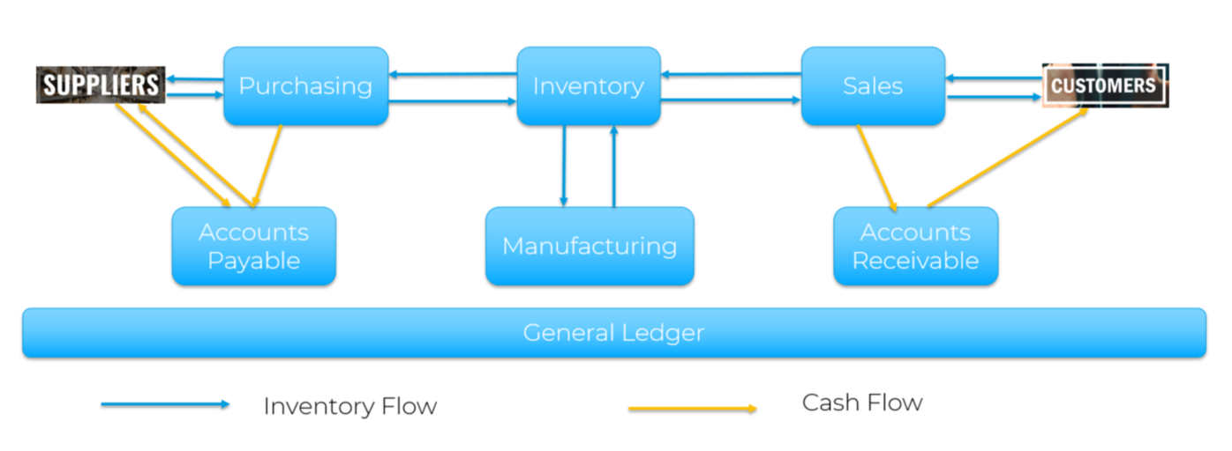

1. AAM Company’s customers wants to buy a product from them. *Sales department* initiates a sales quotation in the ERP System to capture all the sales details. Quote is converted to a sales order.
2. In order to fulfil the sales order, a job order is created by the *Manufacturing department* to produce the required product in the mentioned quantities.
3. If there is a need for the required raw materials, a Purchase requisition is submitted to the *Purchase department* by the factory supervisor.
4. Purchase requisition is raised as a purchase order and is placed with the AAM Company’s suppliers
5. Once the raw materials are arrived, the manufacturing of the parts are completed and the product is either placed in inventory or it is directly shipped to the customer to complete the order.
6. Sales department will register the sales invoice to the *Accounts Receivable* department. The invoice is sent to the customers and the customers complete the payment
7. Purchase department will register the purchase invoice to the *Accounts Payable* department. Payment for the invoice is made to the supplier.
8. All the transactions’ values are logged in *General Ledger*.

# Overall Requirements

## System requirements

* + SQL database to capture the data
  + Reporting tool to create report – Crystal report or any other open source
  + Capable of working on both Web and Client – Server
  + Responsive UI
  + Following screens or facilities to be available
    - Login screen
    - Screens or facilities to capture Master data
    - Screens or facilities to perform sales order related transactions
    - Screens or facilities to perform manufacturing related transactions
    - Screens or facilities to perform purchasing related transactions
    - Screens of facilities to capture or view inventory related transactions
    - Screens or facilities to capture or view finance related transactions

## Data requirements

Below given Master Data are to be captured:

* + Product details such as Raw material, Intermediate products and Finished products are to be stored in Item master (Product)
  + Vendor details such as Vendor ID, Name, Addresses, Emails, Phone numbers etc. are to be stored in Vendor Master (Supplier)
  + Customer details such as Customer ID, Name, Addresses, Emails, Phone numbers etc. are to be stored in Vendor Master (Customer)
  + Warehouse details such as Warehouse Number, Name, Bin details, etc. are to be stored in Warehouse Controls (Warehouse)
  + Bank details such as Bank Code, Bank Name, Bank Account details, Country etc. are to be stored
  + Sales Person details such as Sales Person ID, First Name, Last Name, Contact details, Associated customers etc. should be stored in Sales Persons page
  + Currency details such as supported currency with exchange rates should be stored.
  + All the master data given in the excel needs to be added



# Functional Requirements

## User Creation

* + Option to create Users – Capture first and last name, phone number and Log in credentials.
  + Only added users with correct credentials should be able to login to the system.

## Sales Flow

* + All the master data are created.
  + The Screens for Transactions and Reports are created as given in the below sheet.



* + Quote – Option to create a quote for a new part for an existing customer, attach Sales person. Ability to define part number, revision, Unit of measure, Product class and group code. Upon saving the status should be in ‘Started’ status. Option to change the status to ‘Approved’
  + Sales order – Create a SO from a quote or independently create a Sales Order. A unique id should be generated for each SO
    - From quote – Ability to copy details from ‘Approved’ quote. Details like Customer, Customer detail, Part number, Quantity, price, Product class and Group code, Warehouse details, should be copied over from quote. Option to define PO number, which is a mandatory field. Total should be calculated and displayed. As well, there should be an option to capture the fields in the screens.
    - Independent SO – Ability to capture customer, PO number, Part details, Quantity, Price, Dates and Warehouse Details, Tax and should be able to generate a unique number.
    - Both in quotes and in SO, multiple products can be added. Total should be calculated and displayed.
  + Shipment - Option to create a shipment for a sales order. Upon saving the status should be in ‘Created’ status. Option to change the status to ‘Confirmed’
  + Invoice – Option to create an invoice only from the confirmed shipment record.
  + Report – Ability to generate a quote and AR Invoice.
  + Sales Return

## Manufacturing Flow

* + Part – Option to define part – Is this not a common one for all the modules?
    - capture Part number, description and revision
    - categorize them as Make or Buy part
    - Assign a warehouse (Free field)
    - Do we need to capture different costs?
  + BOM – Option to define BOM
    - Capture the top level part
    - Define sub-part to the top part
    - Define effective date
  + Work Center
    - Define work center – Name and description, Capacity
  + Routing
    - Assign a set of work centers to a Make part
  + JO
    - Create JO from a SO or independent JO
    - Option to change the status of the JO
  + Ship
    - Option to ship the SO to customer
    - Change the status of shipper

## Purchasing Flow

* Vendor details: Vendor Name, Unique Number, Address, Phone number, email, payment details, Contact Person.
  + Create a Purchase requisition
    - Capture Part number, vendor name and address
    - Quantity, date required and price
    - Single and multiple lines?
    - Warehouse?
  + Create Purchase Order
    - Option to copy over from PR
    - Capture part number, Vendor Name and address
    - Quantity, date required and price
  + Receive a PO
    - Option to receive quantity against a PO. Receive full quantity.
    - Move it to a warehouse
  + Report
    - Generate PO, Quantity on hand and transaction reports

## FINANCE Flow

* + Currency Definition – Option to define currency name, symbol and flagging one of the currency as base currency. Ability to define unique id for the currency
  + Conversion factor – Option to define conversion factor for the currency in comparison with base currency. Should be unique for a date range
  + Account number – Option to define unique account number in a fixed format. Assign a unique name to account number
  + Bank - Option to define bank and associate a unique account number and currency to the bank. Ability to define unique id and name to the bank
  + AR Invoice – Option to create an invoice to a customer. Ability to define Customer name, phone number and address. Part number, quantity and Unit price. Define tax and system should auto compute the total invoice value. User should be able to change the status and print the invoice report
  + AP Invoice – Option to create invoice for the vendor. Ability to capture vendor name, phone number, address, PO number, Part number, quantity and unit price. Option to define tax and auto compute the final price
  + Generate an Invoice report

# Conclusion

The purpose of the Aptean ERP system is to efficiently capture all the enterprise transactions in AAM Company and to provide overall picture of all the system activities and to enable proper execution of the same.

As a conclusion, the proposed system will bring benefits to AAM Company. Planning and execution can be done more effectively. It is aims to assist the company in achieving customer satisfaction by delivering the orders on time; thus being profitable.